

Name _______________
Date _______________
Stream _______________

- Draw a map of the site. Label inflows, outflows, and shoreline features.

- Physical observations of the water:
___ Clear ___ Cloudy ___ Litter/debris ___ Algal bloom
Do you have any other observations?

- Wildlife:
___ Fish ___ Birds ___ Insects ___ Amphibians ___ Turtles ___ Domestic animals
Did you observe any other wildlife?

- Water quality
Parameter | Sampling Location
 | Inflow | Outflow | Shoreline
Water Temperature
Conductivity
pH
Phosphate
Ammonia
Nitrate
Total Inorganic Nitrogen

Interpreting Results
- Does the water have enough oxygen to support a healthy fish population?
Dissolved Oxygen Level
< 2.0 | Fish can live for only short periods
2.0 - 3.0 | Few fish can survive for extended periods
3.0 - 5.0 | Fish grow and develop slowly
> 6.0 | Healthful for most fish

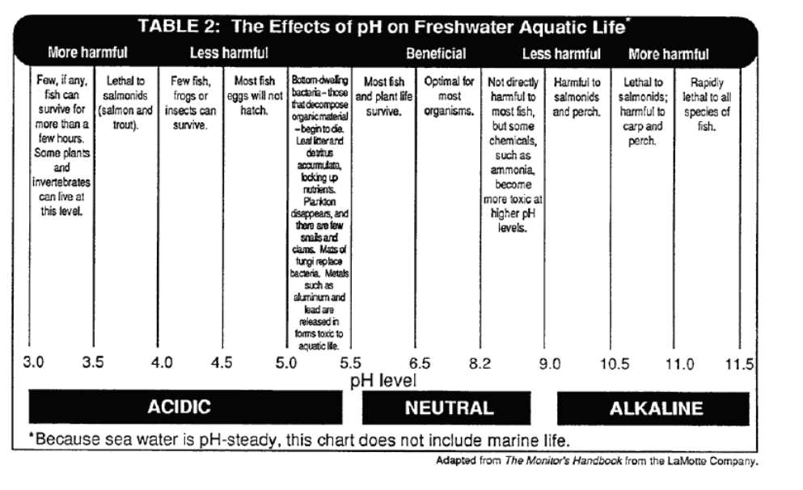

- Does the pH support freshwater aquatic life?

- How does the conductivity compare to other freshwater ecosystems?
Conductivity (µS/cm) | Assessment
0 - 200 | Pristine
200 - 1,000 | “Normal” for most major rivers
1,000 - 10,000 | Saline/impacted condition

- What is the “trophic state” of each lake?
Trophic State | Nutrient concentrations
Oligotrophic | Phosphorus | 0 - 0.01 ppm
Oligotrophic | Nitrogen | 0 - 0.2 ppm
Mesotrophic | Phosphorus | 0.01 - 0.03 ppm
Mesotrophic | Nitrogen | 0.2 - 0.6 ppm
Eutrophic | Phosphorus | 0.03 - 0.05 ppm
Eutrophic | Nitrogen | 0.6 - 1.0 ppm
Hypereutrophic | Phosphorus | > 0.05 ppm
Hypereutrophic | Nitrogen | > 1 ppm

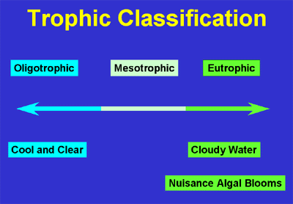

- Does one of the lakes have better water quality than the other? Why?

